HOTSPOT -  
For each of the following statements, select Yes if the statement is true. Otherwise, select No.  
NOTE: Each correct selection is worth one point.  
Hot Area:  
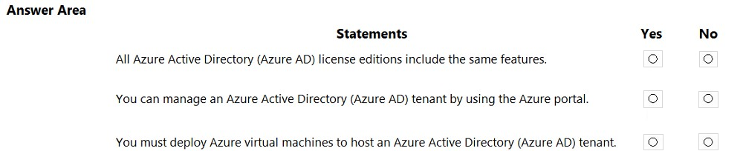

Ans: N,Y,N

HOTSPOT -  
Select the answer that correctly completes the sentence.  
Hot Area:

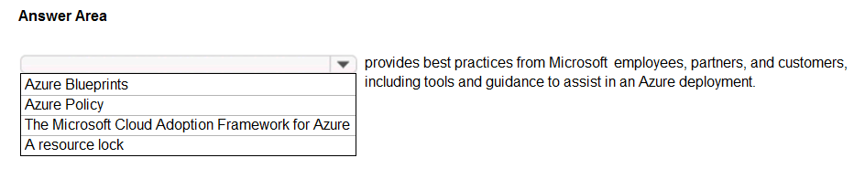

Ans: C

<https://www.examtopics.com/exams/microsoft/sc-900/view/>